**An interesting ECG**

A 46year-old Asian gentleman was reviewed in rapid access chest pain clinic for atypical chest discomfort. He attended emergency department recently for an episode of chest pain when troponin was not elevated. He is diabetic, hypertensive and a smoker (3 cigarettes a day for 20 years). His father died of coronary artery disease in his sixties and he had CABG before his death.

His ECG showed incomplete RBBB and saddle shaped ST elevation in V1 and V2 (Fig 1)

His echocardiogram showed structurally normal heart with preserved left ventricular systolic function

In view of ECG changes and significant risk factors, an urgent outpatient coronary angiogram was arranged which showed only minor atheromatous disease.

Because of abnormal ECG which was interpreted by the attending cardiologist as possible type 2 Brugada pattern, an Ajmaline challenge test was arranged. ECG after ajmaline challenge showed coved ST elevation in V1 – V3 and upper V1-V2 ( V1 and V2 in 2nd intercostal space) Fig 2

There was no history of syncope/palpitation/nocturnal agonising respiration. There was no family history of sudden death.

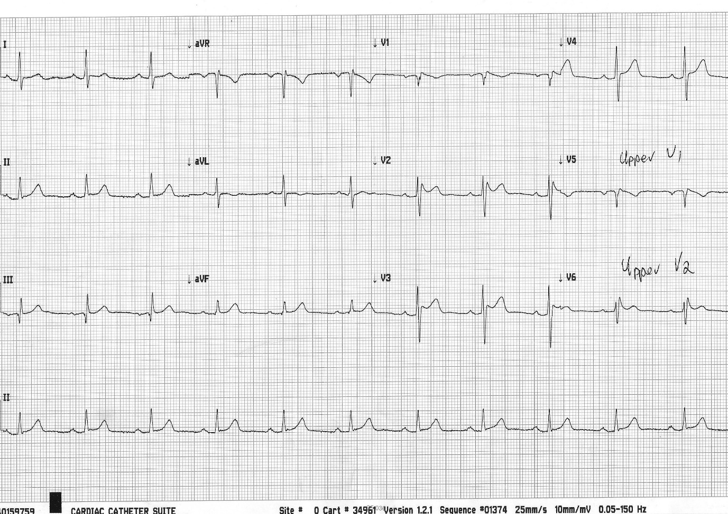

Fig 1 Baseline ECG

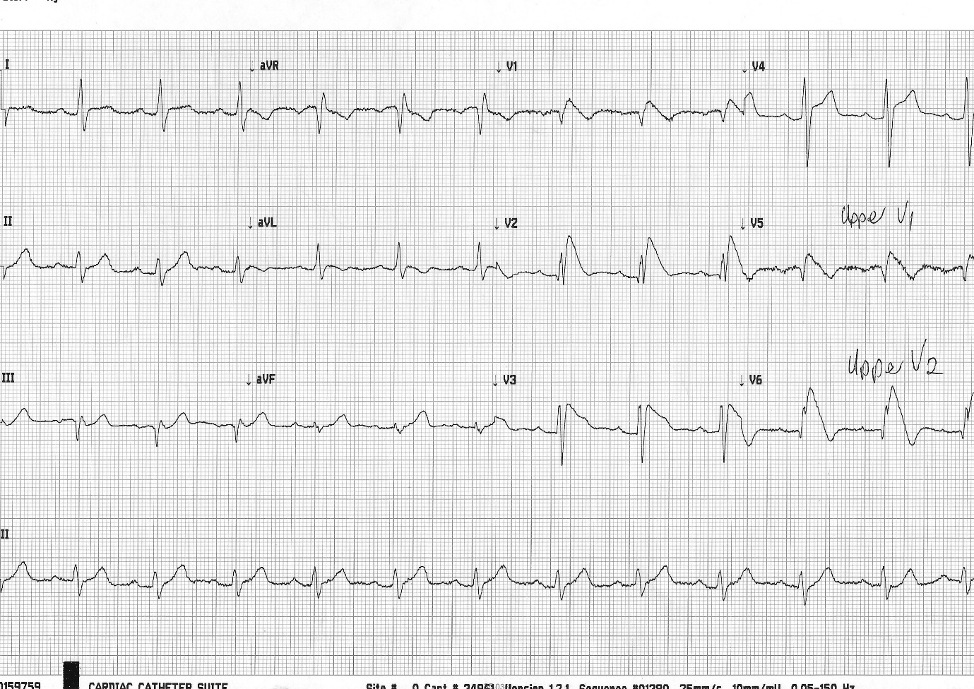

Fig 2 ECG 10 minutes after starting ajmaline

A diagnosis of Brugada syndrome was made.

Management—

● The diagnosis was explained

● Following lifestyle changes were recommended

Avoid Brugada drugs

Prompt treatment of any fever with antipyretic drugs

Avoid large meal/excessive alcohol

● No indication of ICD now

● Risk stratification of asymptomatic patients of Brugada syndrome is quite challenging at present and there is no clear recommendation. Some group has traditionally used electrophysiology study (programmed ventricular stimulation) for risk stratification in asymptomatic patients with a spontaneous BR type 1 ECG pattern. Several non-invasive markers of arrhythmic risk have also been suggested. (1)

The Brugada syndrome is an inherited disorder associated with risk of ventricular fibrillation and sudden cardiac death in a structurally normal heart.

**ESC practice guidelines (2015) on Brugada syndrome**

The prevalence of Brugada syndrome seems to be higher in Southeast Asia than in western countries; the prevalence ranges from 1 in 1000 to 1 in 10 000.

Brugada syndrome is inherited as a dominant trait and shows age- and sex-related penetrance: clinical manifestations of the disease are more frequent in adults and they are eightfold more frequent in men than in women. VF occurs at a mean age of 41 ± 15 years but it may manifest at any age, usually during rest or sleep. Fever, excessive alcohol intake and large meals are triggers that unmask a type I ECG pattern and predispose to VF.

In a recent meta-analysis, the incidence of arrhythmic events (sustained VT or VF or appropriate ICD therapy or sudden death) in patients with Brugada syndrome was 13.5% per year in patients with a history of sudden cardiac arrest, 3.2% per year in patients with syncope and 1% per year in asymptomatic patients.

At least 12 genes have been associated with Brugada syndrome, but only two (*SCN5A* and *CACN1Ac*) individually account for >5% of positively genotyped patients. Results of genetic screening do not currently influence prognosis or treatment.

The only treatment able to reduce the risk of sudden cardiac death in Brugada syndrome is the ICD, therefore, the device is recommended in patients with documented VT or VF and in patients presenting with a spontaneous type 1 ECG and a history of syncope. The prognostic value programmed ventricular stimulation (PVS) has been debated and most clinical studies have not confirmed either a positive or a negative predictive value for the occurrence of cardiac events at follow-up. Quinidine has been proposed as preventive therapy in patients with Brugada syndrome, based on data showing that it reduces VF inducibility during PVS; however, there are no data confirming its ability to reduce the risk of SCD. Recently it has been suggested that epicardial catheter ablation over the anterior RVOT may prevent electrical storms in patients with recurringepisodes, but the data require confirmation before entering general clinical practice.







References and further read-

1. Josep Brugada, MD, PHD, Oscar Campuzano, BSC, PHD, Elena Arbelo, MD, PHD,

Georgia Sarquella-Brugada, MD, PHD, Ramon Brugada, MD, PHD; Present Status of Brugada Syndrome JACC State-of-the-Art Review Vol72 , No9 , 2018

Available at- https://www.jacc.org/doi/pdf/10.1016/j.jacc.2018.06.037?download=true&

2. 2015 ESC Guidelines for the management of patients with ventricular arrhythmias

and the prevention of sudden cardiac death

ABSTRACT5